**Analysis of Airport Data using Hadoop-Hive**

create database airline_2020;

use airline_2020;

1. **creating table airports for airports_mod.dat**:

create table airports(Airport_ID string,Name string,City string,Country string,IATA_FAA string,ICAO string,Latitude string,Longitude string,Altitude string,Timezone string,DST string,TZ string) row format delimited fields terminated by ',';



2.**creating table finalairline for Final_airlines** :

create table finalairline(Airline string,Name string,Alias string,IATA string,ICAO string,Callsign string,Country string,Active string) row format delimited fields terminated by ',';



3. **Creating table route for routes.dat**:

create table route(Airline string,Airline_ID string,Source_airport string,Source_airport_ID string,Destination_airport string,Destination_airport_ID string,Codeshare string,Stops string,Equipment string) row format delimited fields terminated by ',';



**4.loading ‘airports_mod.dat’ data into airports table**

load data local inpath 'airports_mod.dat' overwrite into table airports;

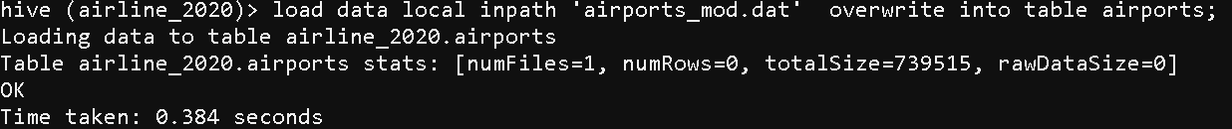

5. **loading ‘finalairline’ data into finalairline table**

load data local inpath 'Final_airlines' overwrite into table finalairline;

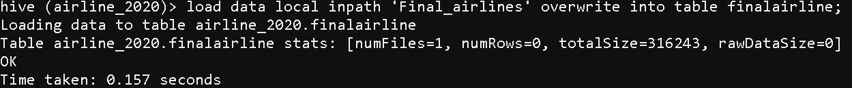

6**.loading ‘routes.dat’ data into route table**

load data local inpath 'routes.dat' overwrite into table route;

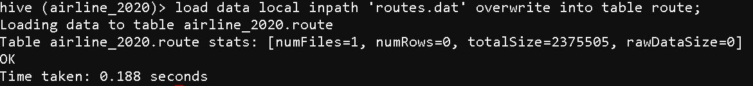

**Problem solution**:

1. **Find list of Airports operating in the Country India:**

* create table indian_airport as select * from airports where Country LIKE '%India%';

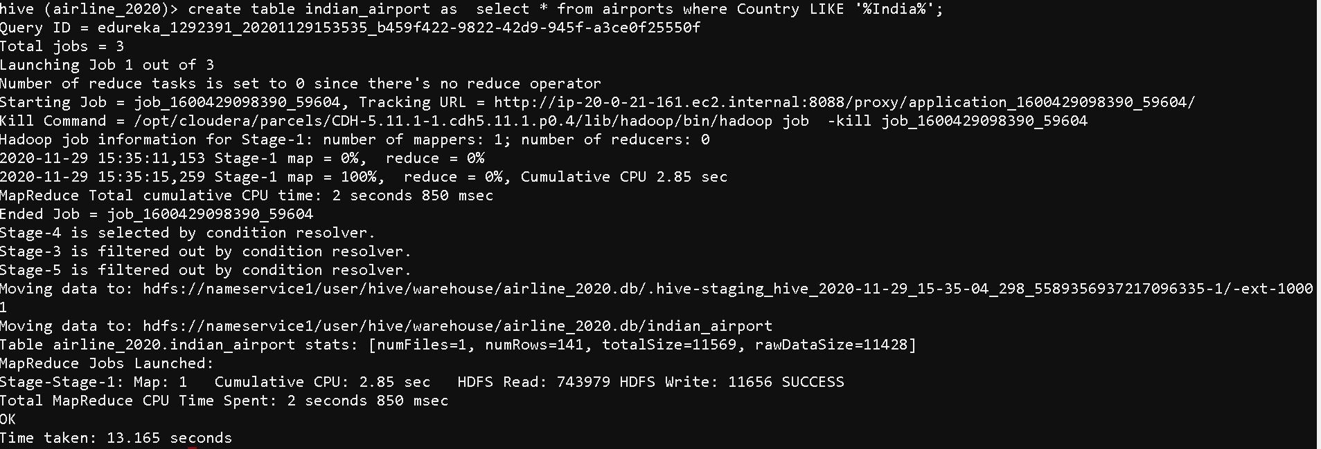

* select * from indian_airport limit 10;

(to show only first 10 values due to large nos of data)

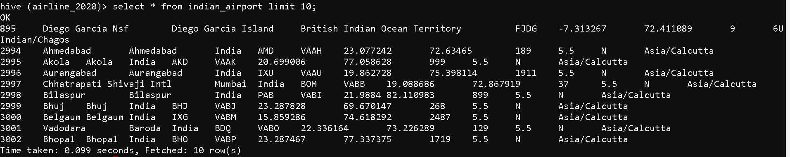

**B.Find the list of Airlines having zero stops:**

create table stops as select * from route where Stops LIKE '%0';

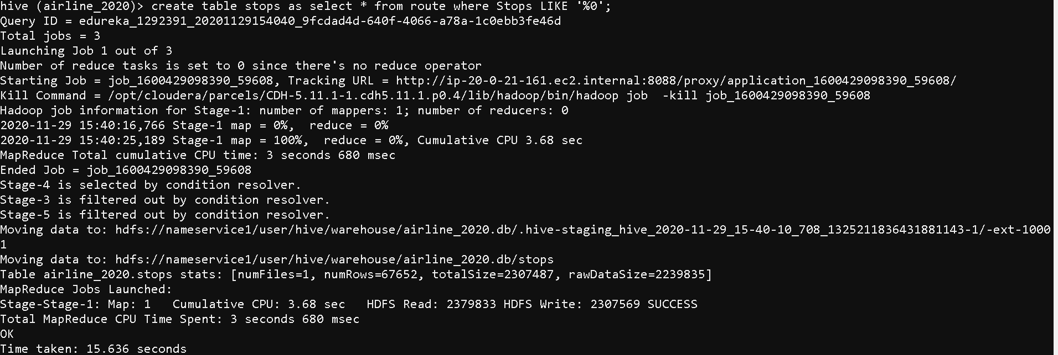

select * from stop limit 10;

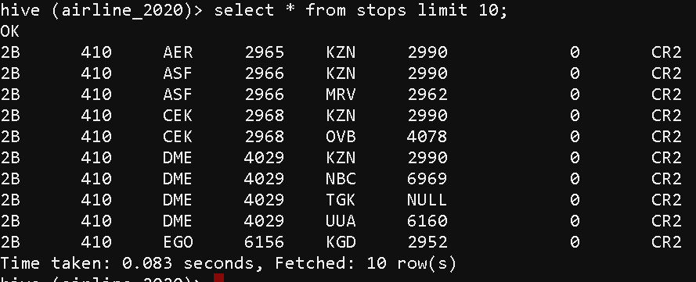

**c.List of Airlines operating with code share**

create table codeshare_02 as select * from route where Codeshare LIKE '%Y%';

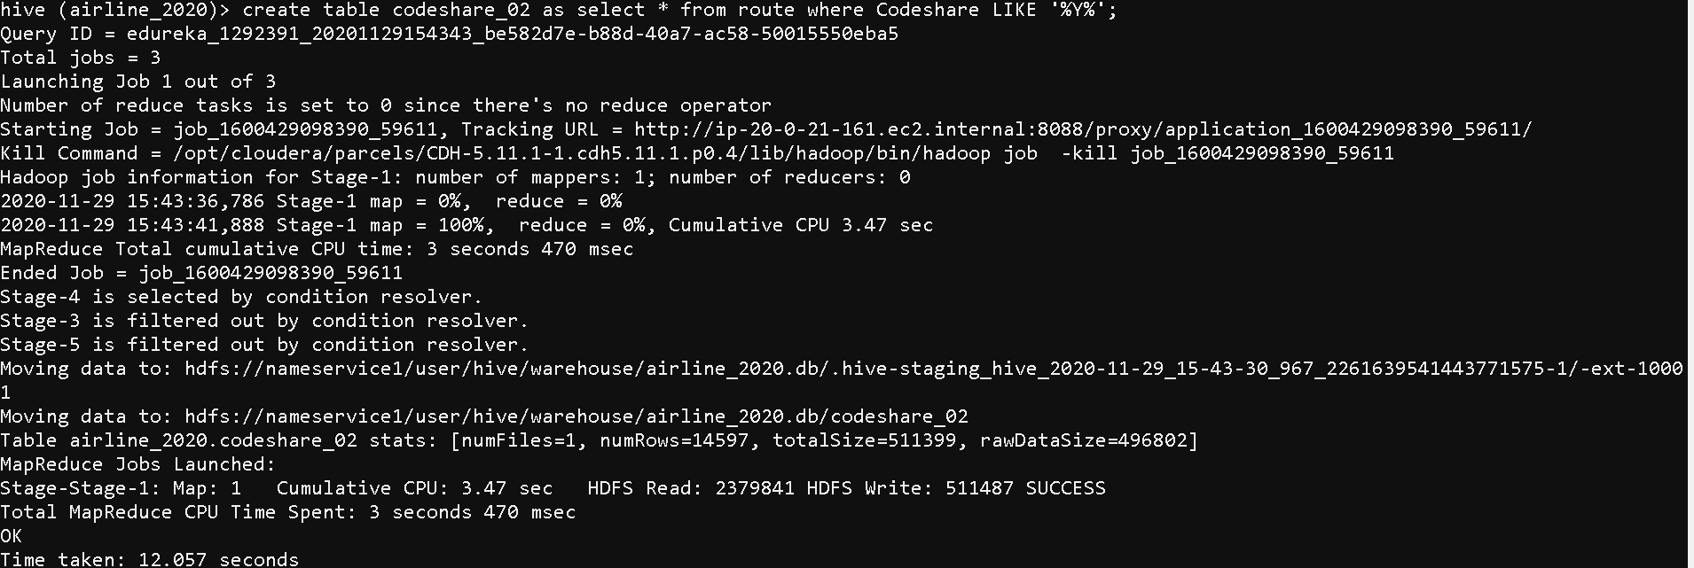

select * from codeshare_02 limit 10;

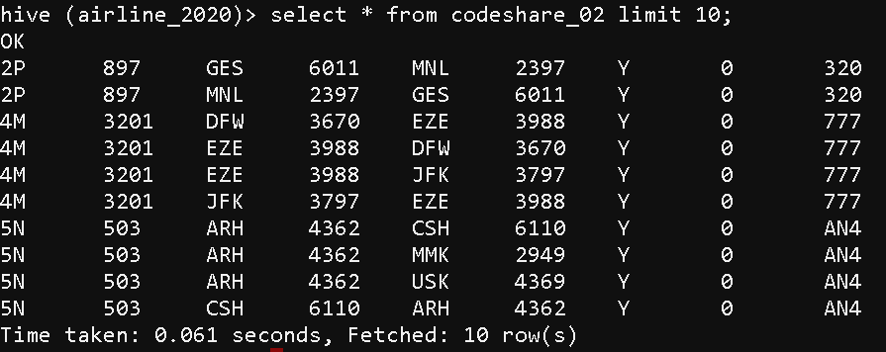

**D. Which country (or) territory having highest Airports**

select Country, count(*) as cont from airports group by Country SORT BY cont DESC;

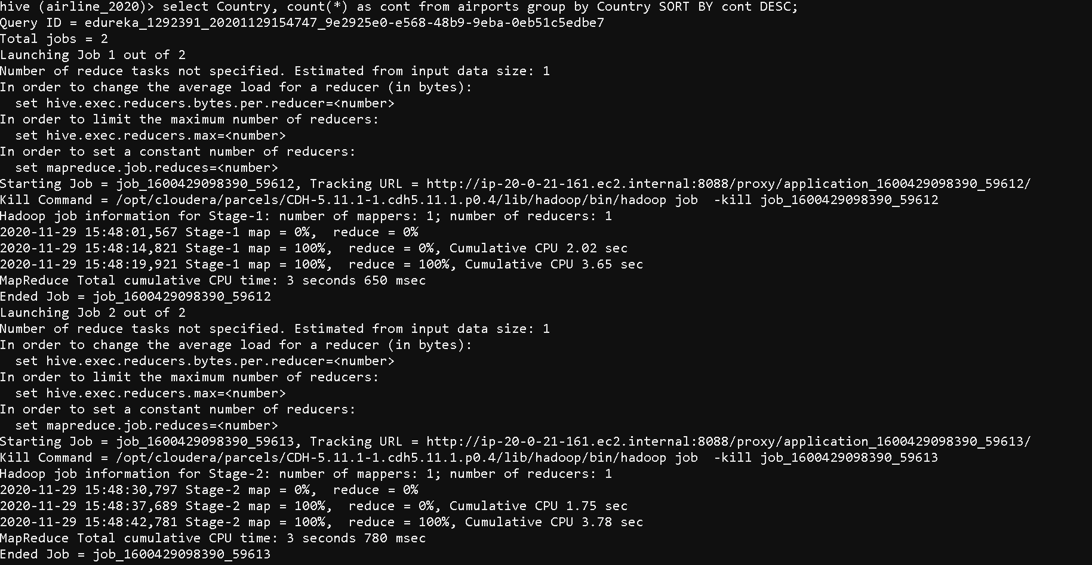

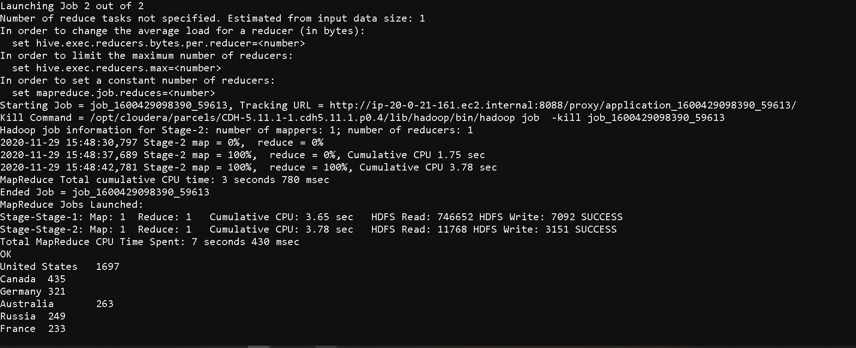

**E. Find the list of Active Airlines in United state**

select * from finalairline where Country like '%United States%' AND Active like '%Y%';

